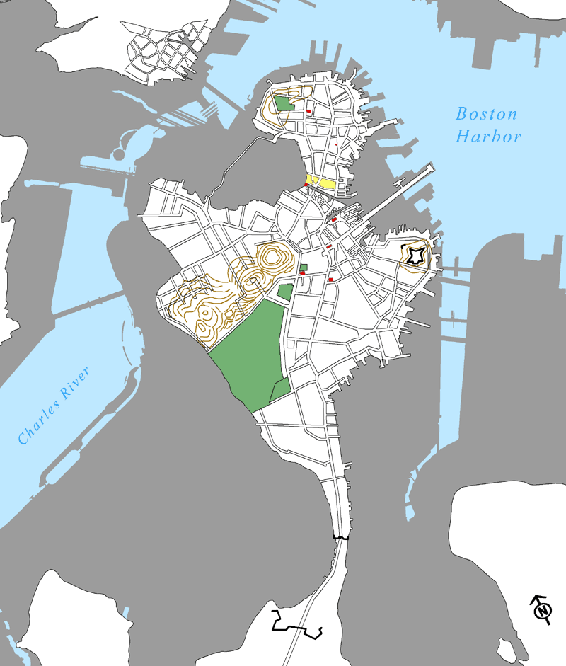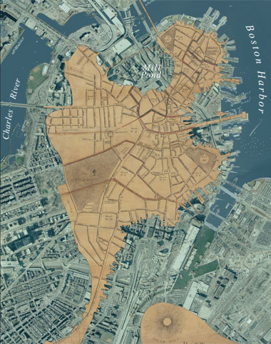**CLS 125 Introduction to Geospatial Humanities**Cross-listed with History 179, Art History (FAH) 0092-04, Archaeology (ARCH) 175

**Spring 2024**

**Day/Time:** TBD, single evening course, 2.5 hours

**Location:** Data Lab, Tisch Library

**Course Instructor:** TBD

**Prerequisites:** None. Students will be expected to have competence in computer use and some familiarity with Microsoft Windows environment and file management.

1775 map of Boston overlaid over 2005 aerial photo

Vectorized 1775 GIS dataset of Boston over 2005 shoreline

**Course Objectives & Goals**The course introduces Geographic Information Systems (GIS) theory, methods, and technology for applications in the humanities in past and present settings. GIS consists of a combination of software, data, methods, and hardware with capabilities for manipulating, analyzing, and displaying spatially referenced data. The course gives primary emphasis to GIS data structures, data creation, geodesy, spatial analysis, and cartographic visualization. It includes extensive exercises to apply concepts presented in the lectures using ArcGIS Pro and ArcGIS Story Maps software. Assignments concentrate on applying concepts covered in lectures and exercises and include a final project that applies GIS to each student’s field of interest.

Students will learn to use GIS to answer spatial questions. For instance, a student interested in urban history seeks to determine those buildings built on filled-land within the City of Boston. The student acquires or creates an historical shoreline of the City of Boston and uses overlay operations to determine those buildings constructed outside of the original Boston shoreline. The student then further qualifies their spatial questions by construction date to identify buildings older than 1900 or by construction materials (brick, wood, concrete, etc.) or by use (residential, commercial, etc.). Likewise, a student interested in environmental history wants to assess the impact of the straightening of the Mystic River in Massachusetts. Using historical maps and historical aerial photography, the student creates a GIS dataset of the historical Mystic River. Through incorporating additional historical GIS data and spatial operations, the student calculates the historical and present landcover and populations impacted by the straightening of the river.

In another example, a student of classical literature is interested in approaches to distant readings of *The Odyssey*. The student extracts locations of places mentioned within the text and calculates the number of mentions of each place and by place type (settlement, water body, temple, etc.). This facilitates visualization techniques to identify significant places mentioned within the text. The student also incorporates additional data and various spatial measures to determine clustering and other possible patterns present in the text. The student also uses the data to visualize the journey of Odysseus.

The major goals of this course are for the student to learn:

* Spatial data structures, georeferencing, and geoprocessing
* Spatial analysis methods for problem solving
* Applications of GIS across the humanities
* Basic concepts in spatial databases and queries
* Principles of cartographic design

By the end of this course students will have achieved the following learning objectives:

* Identify data structures in spatial data (rasters or vectors)
* Identify, locate, and acquire spatial data pertinent to projects in their field of interest, as well as pinpoint significant gaps in or problems with existing information
* Evaluate the appropriateness of the existing data sources for use in a given application
* Understand the data creation process and create geohistorical spatial data sets derived from historical maps, gazetteers, aerial photography, texts, etc.
* Create spatial data from tabular information that includes a spatial reference
* Describe, design, and use basic spatial databases (using keys, joins and queries)
* Use appropriate spatial analysis methods for rasters and vectors as well as linking these methods together in a more complex analytical model.
* Create high-quality maps and associated graphics/visualizations with text that clearly communicate spatial information and the results of analysis
* Design an independent project that incorporates spatial analysis methods
* Appraise spatial analysis in journal articles
* Use appropriate map projection and coordinate system
* Use ArcGIS Pro software with strong proficiency

**Course Requirements and Grading**Students will develop GIS skills through a series of exercises and assignments during the semester. Each student will then complete a final project of their choice. Students will be expected to attend every class and to complete all graded assignments as well as ungraded tutorials and in-class exercises. Completion of assignments and exercises will require additional computer/lab time outside of class.

Grading will be based on a 1000-point scale. Graded assignments and exercises may be turned up to one week late. All late assignments will receive a -10 point deduction and all late graded exercises will receive a -5 point deduction. Details regarding the assignments and requirements for the final project can be found on the Canvas Course Schedule.

* 5 skill-building assignments worth a total of 500 points
* Several exercises (4 graded) worth 150 points
* Class participation worth 100 points
* The final project poster is worth 250 points

**Exercises**  
The course uses weekly exercises tailored for students to learn the topic(s) of each week. Four of the exercises must be submitted for a grade. Each exercise weaves together several components for the student to learn:

* The specific method or concept
* The utilization of ArcGIS Pro software to execute that method or concept
* The application of that method to a specific area of the humanities (urban history, environmental history, literature, archaeology, art history, etc.)
* The relevant types of data and data sources for that application
* The relevant data, map projections, and visualization methods for specific geographic locations as each exercise is situated in a different region of the world, and each exercise is situated within locals of different geographic scales: neighborhood, city, state, country, region, continent, global.

**Assignments**Assignments concentrate on applying concepts covered in lectures and exercises to each student’s field of interest and build toward a final project that applies GIS to each student’s field of interest.

**Final Project**The purpose of the final project is to provide additional experience in collecting, processing, analyzing, and visualizing spatial data. In addition, the students must conduct a literature review as part of their project proposal. The project must use ArcGIS Pro to examine the spatial implications of a research problem. The final project will result in a large-format infographic (poster) or an online interactive story map that describes the research question, data, and methods as well as the analysis and the results. Examples of similar student projects can be found at [Tufts GIS Expo Explorer](https://expoexplorer.it.tufts.edu/).

**Required Readings**

* There is no textbook for this class
* Readings for the course will be primarily from the [ArcGIS Online Resources](https://www.esri.com/en-us/arcgis/products/arcgis-desktop/resources). Using these online materials also familiarizes the students with the vast availability of online resources. Additional readings available through online journal databases open to Tufts students and through public web sites.

**Style Guidelines**  
All written work must be consistent with the style guidelines of one of the two major style guides - the Chicago Manual of Style (MLA) or the Publication Manual of the American Psychological Association (APA). Both provide clear guidelines for referencing and citing other works. You may buy either of these - they will be a useful long-term reference. The [Purdue Online Writing Lab](https://owl.purdue.edu/) also has extremely good guidance to both styles.

**Accommodations for Students with Disabilities**Tufts University values the diversity of our body of students, staff, and faculty and recognizes the important contribution each student makes to our unique community. Tufts is committed to providing equal access and support to all qualified students through the provision of reasonable accommodations so that each student may fully participate in the Tufts experience. If a student has a disability that requires reasonable accommodations, they should please contact the StAAR Center (formerly Student Accessibility Services) at StaarCenter@tufts.edu or 617-627-4539 to make an appointment with an accessibility representative to determine appropriate accommodations. Please be aware that accommodations cannot be enacted retroactively, making timeliness a critical aspect for their provision.